MADDA WALABU UNIVERSITY

INSTITUTION OF TECHNOLOGY

COLLEGE OF COMPUTING

INFORMATION SCIENCE DEPARTMENT



Title: Resident Management System for Baha Biftu Kebele in Robe Town

Group Member

|  |  |  |
| --- | --- | --- |
| No | Name | ID |
| 1 | Mihret Kassa | CCR/0240/09 |
| 2 | Eshetu Lemi | CCR/0123/09 |
| 3 | Lalisa Dabala | CCR/0205/09 |
| 4 | Husen wabe | CCR/0181/09 |
| 5 | Muhammed Aman | CCR/0247/09 |

March, 2011/19

Bale-Robe, Ethiopia.



MADDA WALABU UNIVERSITY

INSTITUTION OF TECHNOLOGY

COLLEGE OF COMPUTING

INFORMATION SCIENCE DEPARTMENT

Title: Resident Management System for Baha Biftu Kebele in Robe Town

Group Member

|  |  |  |
| --- | --- | --- |
| No | Name | ID |
| 1 | Mihret Kassa | CCR/0240/09 |
| 2 | Eshetu Lemi | CCR/0123/09 |
| 3 | Lalisa Dabala | CCR/0205/09 |
| 4 | Husen wabe | CCR/0181/09 |
| 5 | Muhammed Aman | CCR/0247/09 |

Group Research project

Submitted to the Department of Information Science, College of Computing, Institution of technology, Madda Walabu University, in meeting the preliminary Research Project requirement for partial fulfillment for the award of degree of Bachelor in Information Science.

June, 2011/19

Bale Robe, Ethiopia

# Approval Sheet

This Group research project en-titled title “Resident Management System for Baha Biftu kebele” has been read and approved as meeting the preliminary research project requirements of the Department of Information Science in partial fulfillment for the award of the degree of Bachelor in Information Science, Institution technology, College of Computing, Madda Walabu university , Bale Robe, Ethiopia.

Research and scholarly communication management team leader

-------------------------------------- --------- --------------- ---------------------

Principal Advisor Signature Date

-------------------------------------- --------- --------------- ---------------------

Chairman, RSCMTL Signature Date

---------------------------------------- --------- --------------- ---------------------

Head of Department Signature Date

# Abstract

The purpose of this project is to create a system that manages resident’s information under the Baha Biftu kebele in robe town. The study investigates the problems of the current system and a web based system will be proposed. For Recording, filings, providing up-to-date information, security of files and prompt availability of documents for the residents are among the challenges to be made by the proposed system. This project proposal works in the area of ID card, birth certificate, prepare clearance, generate report etc. The manual services poses the problem of time, resource wastage and delays in service delivery to the busy residents of the Kebele. All this information are gathered from different source such as interview with the community who live in Baha Biftu kebele, document by reading different book , for example, under the FDRE constitution , Observation around Baha biftu kebele, Generally, the new resident management system is effective and more reliable than the existing or manual system, since the project being proposed is an automated and web based resident management system and now the system can done accurately than the manual system.

# Acknowledgement

First of all, we would like to thanks to God and we express our deep thanks and gratitude for our group adviser, Mr. Gemechu Wako for providing us with an opportunity to undertake this Project and giving us comments and different advices that helps for our project. Next we wish to express our heartfelt thanks to all those who helped us in the completion of this Project.

# Abbreviations and Acronyms

* BBKRMS:- Baha Biftu Kebele Resident Management System
* PHP: -Hypertext Pre-processor
* HTML: -Hypertext mark-up language
* CSS: -Cascading Style Sheet
* JS: -Java script
* GUI: -Graphical user interface.
* UML: -Unified Modeling Language
* HW: -Hardware
* DB:-Data base
* ID:-Identification card
* ER: -Entity relationship
* DFD:- Data Flow Diagram

Table of content

Contents Page

Approval Sheet…………………………………………………………………………….. i

Abstract ……………………………………………………………………..………………ii

Acknowledgement ……………………………………………………….…………………iii

Abbreviations and Acronyms ………………………………………………………………iv

1. Introduction ………………………………………………………..…………………..1

1.1 Background of the study ………………………………………………………………….1

1.2 Statement of the Problem……………………………………………………………….....2

1.3 Objectives of the Study 2

1.3.1 General Objective 2

1.3.2 Specific Objective 2

1.4 Scope of the study 3

1.5 Limitation 4

1.6 Significance of the Study 4

1.6.1 Beneficiaries of the new system 5

1.7 Definition of Some Terms 5

CHAPTER TWO 7

2 Reviews of Related work (Literature Review) 7

CHAPTER THREE 10

3 Project Design and Methodology 10

3.1 Data Collection Methodology 10

3.1.1 Interviews 10

3.1.2 Observation Method 10

3.1.3 Document Review 11

3.2 System Analysis 11

3.2.1 Existing System 11

3.2.2 Problem of existing system 11

3.2.3 Requirement Specification (RS) 12

3.3.3.1 Functional Requirements (FRs) 12

3.2.3.2 Non Functional Requirements (NFRs) 13

3.3 Feasibility of the Study 15

3.3.1 Technical feasibility 15

3.3.2 Economic feasibility 16

3.3.3 Time feasibility 17

3.4 System design 17

3.4.1 Data Flow Diagram (Process Modeling) 18

3.4.2 Entity Relationship (ER) Model 19

3.5 Software Specification 22

3.5.1 Software requirements 22

3.5.2 Hardware Requirements 22

3.6 Implementation 22

3.6.1 Objective of the implementation 22

3.6.2 User manual preparation 23

3.7 TESTING 24

3.7.1 Introduction 24

3.7.2 Unit testing and result 24

3.7.3 Integration Testing 28

3.7.3.1 Incremental Testing/Top down testing 28

3.8 Documentation 31

Chapter Four 32

4 Result and Dissemination …………………………………………………………….32

4.1 Project Layout 32

4.2 User Interface 33

5 Conclusion and Recommendation 38

5.1 Conclusion 38

5.2 Recommendation 38

Reference 39

Sample code 40

APPENDIX 45

**List of Figure**

Figure 3:1 DFD for creating account for Resident and Registration. 18

Figure 3:2, DFD for send certificate request and receiving certificate 19

Figure 3:3, ER diagram for Resident Management System 20

Figure 3:4, incorrect password and username 23

Figure 3:5, Correct User name and password Result 24

Figure 3:6, After Correct username and password admin page 25

Figure 3:7, Incorrect Id card Certificate 25

Figure 3:8, Incorrect Id card Certificate 26

Figure 3:9, Login and view withdrawal Certificate 28

Figure 3:10, Login and change password 29

Figure 4:1, project Layout 31

Figure 4:2, User Interface for home Page 32

Figure 4:3, User Interface Login Page 33

Figure 4:4, User Interface Admin Page 34

Figure 4:5, user interface for viewing Withdrawal certificate 34

Figure 4:6, User Interface Clark Page 35

Figure 4:7, User Interface Resident Page 36

Figure 4:8, User Interface for View ID card 36

CHAPTER ONE

# **Introduction**

The kebele Resident Management System (KRMS) is introduced as a computerized system to ease the pressure on its user in which information system manually is difficult, because it causes information inconsistency and data integrity problem. To overcome this information in consistency and integrity we need to have web based data management system. The new resident application system can help to eliminate the paper based applications thereby speeding up processing as details which can captured in the database This system is prepared for the project to design web based Kebele resident management system. The manual system based has different problems. So, our objective is to reduce those problems that can be occurred in the manual system by developing web based system. We can say that our new system can provide fast & modern service for different users. For this, to do this information can be gathered from different data collection methods and tools.

## **Background of the study**

This system is already developed for Baha Biftu Kebele in Robe town. Robe town has three Kebele. Baha Biftu is one of the kebele found in Robe town in Oromia region which is 430 km away from Addis Ababa. They empower to handle many services like Giving ID cards, birth certificates, Death Certificate and Clearance etc. As a result, the society of Baha biftu has benefited from such an arrangement as most services are brought closer to the community; there by avoiding lengthy bureaucratic procedures delays that makes the number of days large to perform a job during the old system.

## **Statement of the Problem**

The main problem behind the manual system is that the work is paper based.

This creates a lot of problems like:-

* Due to redundant data, more space is occupied by file cabinet
* It takes more time to find the particular file or data amongst those much bulky manual recording system and residents are not able to access their personal information..
* Lack of effective and efficient service for the Resident.
* The manual system is costly; the system takes a lot of hard copies and other instruments.
* Problems of ID card: for renewal and addressing a new ID card takes time on cross checking, residents may have two and more ID card from different Kebele.
* Problems of certificate addressing like Birth certificate, Death certificate
* Problems of controlling, retrieving and managing of Files. All transactions are done manually. Recording of information or documents of residents were kept in their paper-filing system
* Lack of security: - Documents can be maliciously accessed by anyone and difficult to access the resident information when needed at short notice and removal of resident record.

## **Objectives of the** **Study**

### General Objective

The general objective of this Project is to develop web based Kebele resident management system for Baha biftu Kebele in Robe town which solves the above mentioned problems that occurs in the manual system or existing system.

### Specific Objective

The specific objectives of this project which includes:

* Analyze the existing system such as the identification and assessment of the major constraints related to the population registration and giving of the security identification card and other government services.
* To keep the overall records associated with the resident information in a permanent database.
* To increase income for the kebele by reducing printing and duplicating materials.
* Implement the system based on our design to achieve the desired goal.
* Designing a database for the system that can hold all information of the kebele administrations.
* Avoiding data redundancy and inconsistency.
* Maintaining security of the kebele information.

## **Scope of the study**

The scope of this project is developing Kebele resident management System for Baha Biftu Kebele in Robe town only. It has the following activity: -

* Registration of Kebele residents/population information.
* Prepare Clearance for legal resident who needs to transfer from one place to another place.
* Online ID card request.
* Provision of security identification cards to residents.
* Renewal of the identification cards.
* Give certificates such as death, birth and other supportive letters to different government and non-government organizations for residents.
* Register residents who withdraws residency.
* Build a secure database system

## **Limitation**

Limitation describes what operations or functions the final result of the system can’t perform due to different constraints. As a result, the system may not include the following services: -

* The system not include related to land.
* Tax collection and other services that are not explicitly mentioned in the scope are not included in the study.
* The study is limited only to the Baha Biftu kebele administrations.
* The system cannot access with their local language i.e. limited only to English language.
* The system is limited only when electric power and network connection is available.

## **Significance of the Study**

This study is need for increasing efficiency in reducing time, human power and running cost, monitoring and recording of the activities in Kebele by introducing a computerized kebele resident management system. Besides, this study is significance because its conclusions would be useful to:

* The paper waste can be reduced by using cloud platform and electronic format documents instead of printed mails or letters.
* Providing a well-organized and guaranteed record keeping system with minimum space and effort need.
* Reduce wastage of material such as paper, pen, pencil, human power and time and cost.
* Reduce data retrieval time during Searching of Resident Information.
* Make the performance of the work more efficient and faster than the manual system.

### **Beneficiaries of the new system**

This project is beneficial to the following user:

* Baha biftu kebele Administrator. Administrator needs to have the necessary information from the community and provide immediate information to residents. Better public service to its constituents can be achieved.
* Workers. Employees of Baha biftu kebele will have resident’s data; give prompt services to its residents, and secure important files.
* Baha biftu kebele Community. Using the system the community assures a better service from their kebele.
* Developers:
* Obtain knowledge and experience from it.
* Use it for partial fulfillment of degree program.
* Gain income when this project system will be completely done accurately.

## **Definition of Some Terms**

Kebele house – in this study refers to a housing unit that has been nationalized by the Ethiopian government according to proclamation 47/1967 which nationalized all, extra houses‟ and are now administered by Kebeles (presently Woredas).

Residential houses- means house which are used for residential purpose only.

Actor- represents anything or anyone participates in the system. This may include people’s that are external to system.

Rent provider- is a person who works in government office or is an agent of the government given responsibility to rent the house.

Tenants- are a person who has a rental agreement to rent a house with the office or with an agent who administers the house.

Resident, aperson coming into a place with intention to establish his domicile or permanent residence,

 And who in consequence actually remains there.

Residence: a palace where one makes his/her own home. However, a person may have his/her state  of "domicile" elsewhere for tax or other purposes, especially if the residence is for convenience or not of long standing in a corporation law.

Clerk: a person whose job is to keep the records in an office, shop or store etc.

CHAPTER TWO

# Reviews of Related work (Literature Review)

This chapter reviews literatures written on resident to better understand what is meant by it internationally and allows the reader to bring up the date concerning the state of project in the field and familiarizes to any contrast perspectives and viewpoints on the topic. For the development of this online kebele resident system we have observed some information’s about the kebele that already using the residential manual system as one of tools to provide these facilities for our Baha biftu kebele in order to control and compile resident full information. Actually, in Baha biftu kebele resident management system is not the innovation, rather it is invention (improvement) of the manual or tedious system.

(1)A Kebele house is affordable public rental housing provide by the Ethiopian government for its citizens. The study also looked into a recommendation for a public housing system for tenants to stay in a rental building for a few years which is a transition unit until they will be able to buy a house by working and saving up.

Problematic issues in rental housing

1. Discrimination against Some Categories of Tenants
2. Rent Level
3. Quality of the rental housing Stock
4. Inner-City Problems
5. Legal Issue
6. Mobility and eviction

Public housing is different from country to country as we can see from the international case studies. For example, in the Netherlands and France people with high income cannot rent governmental owned public housing if they can afford to rent somewhere else. From the UK public housing, there is a time limit on how long a tenant could stay in the house. [1. Housing and Sustainable Development. Haileyesus, Yohannes Balcha. s.l. : Ethiopian Institute of Architecture, Augest 2014.]

(2)The University of British Colombia the Resident Management System has been designed to provide a customizable and scalable solution, giving PGME the ability to adapt as business needs change.  (RMS) is an administrative system implemented by the Faculty of Medicine to help PGME program staff effectively manage academic and administrative records for the growing number of residents across the province. The objective of RMS is to reduce the administrative time and effort required to manage resident information, track rotation exceptions (i.e. leaves of absence, part-time training), and streamline the processes for promotions, statutory holiday pay, intake, registration, and payroll. RMS Governance Committee Mandate to:

1. Improve the efficiency and enhance the quality of postgraduate administrative management.
2. Champion and promote RMS to all PGME programs.
3. Act as a representative on behalf of the users of RMS to ensure the accurate and consistent management of resident information.
4. Review recommendations and address concerns escalated by MedIT and Educational Administrative Systems Support.
5. Evaluate and recommend the development of new features and changes to RMS to ensure the system remains current, relevant and sustainable. [2. Resident Management System (RMS). UBC Faculty of Medicine. london : s.n., 2019, Vol.] VERSION P2.1.

(3)Under Alberta’s 10-year plan to end homelessness by 2019, funding is being provided to community based organizations in the seven major cities, which work with community partners to deliver services necessary to meet the unique needs of the homeless. Housing is a key approach in this plan. Funding is used for supports such as intensive medical, psychiatric and case management services to help people resolve the underlying causes of their homelessness. These services are a key to ending homelessness, because they help those who are now housed to stay housed and keep on track to independence. The literature is unequivocal in concluding that residential programs are most likely to be successful when they are located within natural communities, and when they provide opportunities for community reintegration. The most significant barrier, besides an adequate inventory of community supported housing, is the anxiety-based forecasting of economic devaluation, increases in crime and other concerns that are part of NIMBY [Not in My Back Yard][ 3. HOUSING AND SUPPORTS FRAMEWORK; INITIATIVE; and CREATING CONNECTIONS:. Celina Dolan, Anita Friesen,Amber Gallant,Keith Hughes,Jim Merchant,Doug Vincent,Charmion Whyte. May 4, 2012]

(4)The increasing interest in smart home technologies has created a need for a comprehensive literature survey. The challenges associated with smart home energy management systems and possible solutions are examined, and the energy factors that contribute to a customer’s electricity bill are discussed. Review of the literature related to energy management system scheduling with respect to its control, automation, and communication. A smart home incorporates sensors, actuators, middleware, and a network and has two major interacting components: a smart network and a smart load the primary objectives of a smart home are to increase home automation, facilitate energy management, and reduce environmental emissions. [4. Smart Home Activities:. Ameena Saad al-sumaiti, Mohammed Hassan Ahmed & Magdy M. A. Salama. s.l. : Taylor & Francis Group, LLC, feb 05, 2014. 1532-5008 (Print) 1532-5016 .

(5)The increasing demand for electricity and the emergence of smart grids have presented new opportunities for home energy management systems (HEMS) in demand response markets. HEMS are demand response tools that shift and curtail demand to improve the energy consumption and production profile of a dwelling on behalf of a consumer. HEMS usually create optimal consumption and production schedules by considering multiple objectives such as energy costs, environmental concerns, load profiles, and consumer comfort. However, the effectiveness of the methods in the existing literature can be difficult to compare due to diversity in modelling parameters, such as appliance models, timing parameters, and objectives. [Home Energy Management Systems:. Dr. NW, Calgary AB T2N 1N4 mdbeaudi@ucalgary.ca. s.l. : University of Calgary, december 22, 2014.].

# **CHAPTER THREE**

# **Project Design and Methodology**

## **Data Collection Methodology**

### **Interviews**

This was the most exhaustible method of data collection. The team used their data superior collection skills to extract data out of the kebele management team, the kebele employees and the kebele’s residents (customers) at the moment of data collection. The interviewers created conducive environment in which the interviewees could feel free to let out the best they could that helped the team come up with the most effective system to fulfill their needs. Among the data collected the following was highlighted to be of a great consideration:

The residents’ feelings about the current management of the Kebele and The employees’ comfort ability with the proposal of introducing a new computerized system. Many computer illiterate employees had fears of replaced displaced by the computer literate employees but they were assured of their survival should they be ready to prove their competence in their activities. The management’s dire need for management of the kebele’s proceedings was put into consideration by the system developers and this interview was conducted for handling records of the residents and the administrator of the kebele in order to know the constraints of the current system.

Beginning with the basics, the team ask questions which describe and provide a background of fundamental details about the system.

### **Observation Method**

The team closely observed the kebele’s activities as the residents are served at the kebele and how the management carried out its managerial activities. The team found out that the kebele indeed was in a dire need for automation of its activities to realize its maximum potential. The customer admission and service process was not well managed by the current manual system; hence, the team came up with this system to clearly outline the management boundaries of the all departments. It will also be conducted as to experience real scenarios of residents doing transactions in the Kebele.

### **Document Review**

Existing official forms will be collected and collated to better understand the system structure that means, both the residents and staff documents were revised. Several data entry errors and retrieval problems were encountered. The system has put into consideration an error recovery strategy that will ensure maximum data integrity.

## **System Analysis**

### Existing System

Presently all the registrations are done manually. If a person wants to make registrations like birth, death etc. he/she should directly contact the corresponding office. The main disadvantage is that there will be lot of difficulties for the citizens. So, all these procedures will be a time consuming. The manual system of Kebele has no automated system they are working through manual file handling system and data is stored in written document and delivered in system through paper in form of document and letters. This kebele knows each and every member by their Identification card (ID), house number and their Registration number.

### Problem of existing system

Within the Manuel system recording the details of various activities of user is completely manual and entails a lot of paper work. Each resident has a file that contains the house number, sex, date of birth, address, expected deposit, occupation and status.

The manual system only provides text based interface which is not as user friendly as Graphical user interface. Since the system is implemented manually, the response is very slow.

The transactions are not secure as papers may get lost or damaged. Hence, there is need of reformation of the system with more advantages and flexibility. The system eliminates most of the limitations of the existing system.

* Difficult for retrieve personal information of Resident.
* Data is not well protected and organized
* Time consuming
* High space required to store data
* Work overload for Officers
* Data is not accurate
* They are performing every task manual.
* Employee handles more problems due to faulty error, Security related problem: due to manual system the protection is less.

### **Requirement Specification (RS)**

### 3.3.3.1 Functional Requirements (FRs)

Functional requirement specifies something the system should do. A function is described as a set of inputs, behavior, outputs, data manipulation and processing and other specific functionality that define what the system is supposed to accomplish.

Generally, the functional requirements for the new system that will replace the existing system include:

* Data storage and retrieval: All the resident files or information should be kept properly in well-organized data base; so that retrieving these files will be easy and faster.
* User management/authentication: the system allows user creation and user management.
* The system can register new residents and those who withdraw residency.
* The system can register family members
* The system can prepare, Give ID card and renew it
* The system can able to give certificates and recommendation (supportive) letters.
* The system can able to Search, updating and deleting records.
* The system can enable to give clearance for the resident.
* The system can enable to view comment and withdrawal request.

### 3.2.3.2 Non Functional Requirements (NFRs)

* Non-functional requirement specifies how the system should behave and that it is a constraint upon the systems behaviour.
* It describes how the system works.
* Some typical non-functional requirements are listed below:

Performance: -

* The system is very fast since it is automated.
* The software shall support use of multiple users at a time.
* It works very well with short response time, high throughput and high availability.
* Reduce costs and time waste by providing access to system in available place and time where Internet connection is available

User Interface: - The developed system provides web application user interfaces that are compatible browsers like Internet Explorer, Mozilla Firefox, Google chrome, etc.

Security and Access Permissions: - The system provides or contains user name and password for each users based on their privilege. This performs the following activity: -

* Authenticated user with predefined access right will only enter to the information related to database.
* This system is provided with authentication without which no user can pass. So only the legitimate users are allowed to use the application.
* If the legitimate users share the authentication information then the system is open to outsiders.
* Every users should use strong passwords especially administrator.
* User must enter valid user name and password to login to system. Without this, access to the system is denied.
* Data is encrypted for security.
* System allows only registered users to access kebele management system

Backup and Recovery: - When team member standard to develop a system they must have to put use a backup mechanism by using removable flash disks, external hard disks or CDs.

Resource: - The system has a resource that requires having the following performance characteristics

* The server and the client must have memory space.
* The server and client must have process speed.

Usability:-The system shall be very easy to learn, needs basic computer knowledge to use and has a help menu to guide the user.

Availability: - There is no delay in the availability of any information, whatever needed, can be captured very quickly and easily. The server should be always on to be available except absence of electric power and network connection.

Error handling: -This system handles error done by the user giving error message when the user enters wrong inputs. In addition, the system provides error handling mechanism on the ways system interacts with data base and on input accepter fields.

Quality issue: -Information in database should be accurate and updated.

System modifications: -The system should be easily modifiable

Reliability: - Good validations of user inputs will be done to avoid incorrect storage of records.

Portability: This system can be installed in any personal computers supporting windows operating system platform.

Flexibility: The system keeps on updating the data according to the transactions that takes place.

Robustness: -The system should be difficult to break even if deliberate in terms of data being entered being of the correct data type. And the system does not crash at the slightest disturbance.

Correctness: -The system should perform according to defined specification.

## **Feasibility of the Study**

This project has budgets and deadlines; the analysis of factors for feasibility forms the business case (analysis of the assumptions like resource availability and potential problems and system cost and benefits) that justifies the expenditure of the resources on the project.

### Technical feasibility

Technical feasibility is the process of assessing the development organization’s ability to construct a proposed system.

The system developers understand the scope; objectives including specific objectives and the users have technical capability/ability to use this system.

Usually new systems established in order to overcome the technical illness of the previous system. In the same way, this system is technically big enough to be applied easily to the problem identified in the existing system. In addition; both hardware and software for this system are highly available and can be owned with small cost. Therefore, it can be concluded that the system is technically feasible.

### Economic feasibility

It is the process of identifying the financial benefits and costs associated with the development project.

When the team can be analyses the system by comparing the cost with the benefit (the enterprise can get by using the proposed system), surely the benefit out weight the cost. The cost of developing a full system, including software and hardware cost for the class of application being considered should be evaluated. So, the benefit that obtain by using the system can be categorized as tangible and intangible.

Tangible benefits: it is benefits derived from the creation of an information system that can be measured in birr or dollar and with certainty such as:

* Using less man power than the existing system.
* Increase speed of activities and competence.
* Reduce cost and avoidance
* Error reduction.

Intangible benefits are: is a benefit derived from the creation of an information system that cannot be measured in birr or dollar easily and with certainty such as:

* Knowledge required by project developer.
* Facilitating information processing.
* Increased employee morale.
* Increased organizational flexibility
* Updating information.
* Increasing the competitiveness of the individual.
* Improved productivity.
* Improving the morale of our team.

Therefore the team decided the proposed project is economically feasible.

### Time feasibility

Time feasibility is the process of assessing the degree to which the potential timeframe and completion dates for all major activities within a project meet organizational deadlines and constraints for affecting change. The schedule for this project will be feasible due to proper information exchange between the developing team and the Advisor. And also the time set to develop the application is enough to complete at the predefined day and time since the project is supposed to be completed in 8 months i.e. 3 months for proposal documentation and the rest 3 months for implementation and testing.

We have so many fixed schedules to work together the project with all groups within each day and for the simplicity and fast developing purpose.

## **System design**

Some of the design goals are:-

Security: - Unauthorized access to the system, by any means, should be restricted. Hence, group level system security will be implemented to prevent unauthorized personnel from accessing the system. Database security, to prohibit the database from an unauthorized access, should be implemented using security feature of Microsoft SQL Server. The database should only be accessed through the system

Flexibility:-.The system should be flexible in terms of adding and deleting module or functionality to the system or from the system because each functionality is independent to each other &does not affect the system.

Fault Tolerance:-The system should be able to give response (error message) when the user enter incorrect input. This recommends the user to enter correct input.

Accuracy: - The system should give only valid result, if no data is found with the specified criteria the system should give invalid Message Display.

Usability: -The new system is easy for the user to use it and learn it.

Generally, in order to design this system we used an object oriented approach (methodology) such as Unified Modeling Language for Entity relationship diagram, and smart drawer for data flow diagram.

### **Data Flow Diagram (Process Modeling)**

Manager: when the user wants to have an account the manager searches the resident information from the database, and if the resident information is present and legal person then he create the account and give for the resident.

Clerk: has the responsibility to register resident full information and update and delete all the entire information.

Resident: resident needs to have an account and give full information about his/her self for clerk.

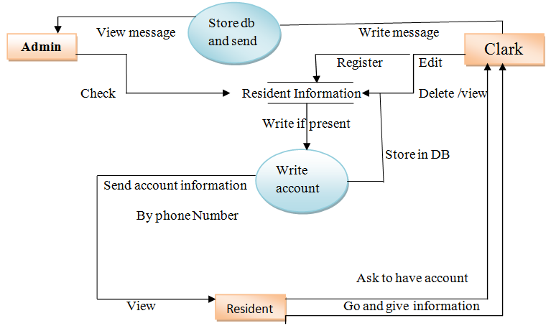

Figure 3:1 DFD for creating account for Resident and Registration.

Manager: when the resident wants any certificate (ID, birth, death) and ask to manager and manager also search or check the person is legal or not. If the person is legal he /he will give the certificate unless not.

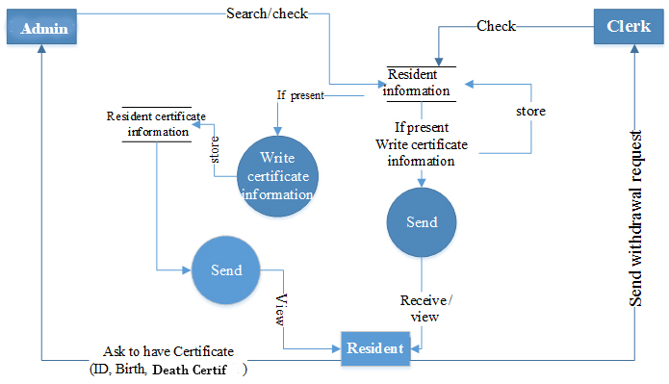Clark: the clerk is responsible for storing full data of resident and give withdrawal request or clearance when the residents want to move from one place to another.

Figure 3:2, DFD for send certificate request and receiving certificate

### Entity Relationship (ER) Model

The Entity that can be occurred in the system can be listed below:

Admin – have his or her own attribute such as full name (Full name, Middle name and Lname), age, sex, address, id and date of birth.

Clerk – have his or her own attribute such as name (Full name, Middle name and Lname), age, sex, address, id and date of birth and phone number.

Resident – have his or her own attribute such as name (Full name, Middle name and Lname), age, sex, address, id and date of birth, job, woreda, zone, region, house number, phone number.

Certificate – Resident id, certificate id, Resident kebele, Resident name (Full name, Middle name and Lname).

User account - User name, password, user id, user type.

Comment – date of post, time of post, sender email, comment id, sender full name.

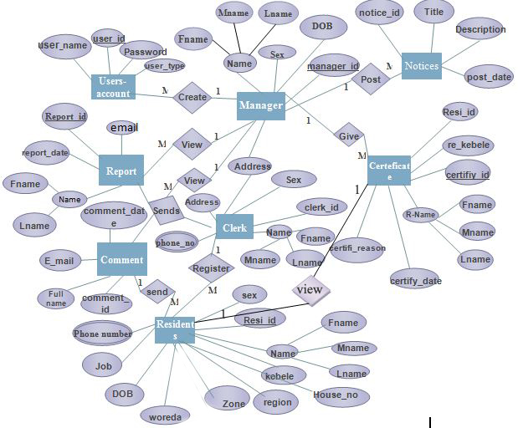

Figure 3:3, ER diagram for Resident Management System

## **Software Specification**

### **Software requirements**

* Notepad++: - for writing code.
* XAMPP Server: - used as server which stores data.
* Edraw max: -For designing UML diagrams associated with the project.
* Microsoft office 2007: - for preparing documentation.
* Mozilla Firefox, IE, Google Chrome, Opera: - Browsers for executing the code.

### **Hardware Requirements**

The kebele should have desktop computer having typical storage capacity and processing speed.

* Flash disk: -used for transferring data.
* CD-ROM: -for storing data or file.
* Personal Computer: -used for developing software, installing application that is used for our project like notepad++, edraw max, Microsoft office and so on.
* Cable
* Printer: to print the document of the project
* Scanner: to change pictures from hard copy to soft copy
* Digital camera: to take necessary pictures for graphical interfaces

## Implementation

### **Objective of the implementation**

The main objective of implementation is to change the points we have been discussed earlier i.e. from software requirement specification (SRS) and the system design part of the document to implement or

The objective of Systems Implementation phase is to convert the final physical system specifications into working and reliable software and hardware, document the work that has been done, and provide help for current and future users and caretakers of the system.

Hardware and software acquisitions for Implementation

For this project implementation, the following hardware and Software’s are used.

Hardware:-

* + - * Printer: For printing Documentation
      * Computers
      * Flash Disk(4 GB)
      * RG 45 cable

Software:-

* Microsoft SQL server 2005
  + - * Microsoft office2007
      * Macromedia Dreamweaver
      * Xampp server
      * Firefox browser
      * Adobe photo shop
      * WordPad

### **User manual preparation**

Since the system is web based and easily user friend, everything important for the users will be explained and implemented while giving short training when the system is deployed. There is no need of preparing full user manual because it is only deployed (hosted) on a single machine that is server. So, anyone who can access the internet can also access the system easily within the given permission or role.

## TESTING

### **Introduction**

The purpose of testing can be quality assurance, verification and validation, or reliability estimation.

After the integration of modules, the whole system was tested. The resident information system was tested using a local host and it worked properly. Sample resident details were imputed into the system and it was stored in the database and viewed using the view of resident profile.

### **Unit testing and result**

Every module of the System is separately tested. I.e. the team tests every module by applying some selection mechanism. Through this mechanism every modules gets tested. If an error occurs correction will be taken without affecting another module. We have tried to test UI screens of our system that needs to verify screen elements that appears on the screen.

* . Incorrect password and username

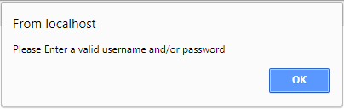

Figure 3:4, incorrect password and username

* correct password and username

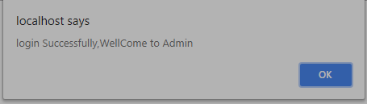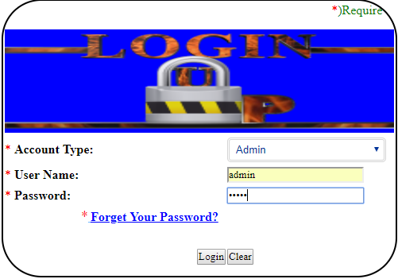

Figure 3:5, Correct User name and password Result

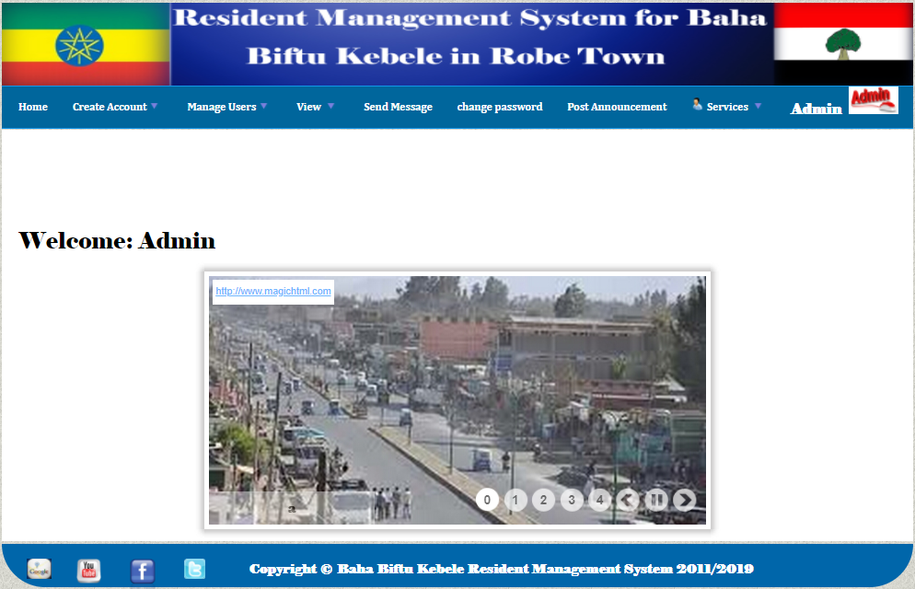

Figure 3:6, After Correct username and password admin page

* Incorrect Id card form

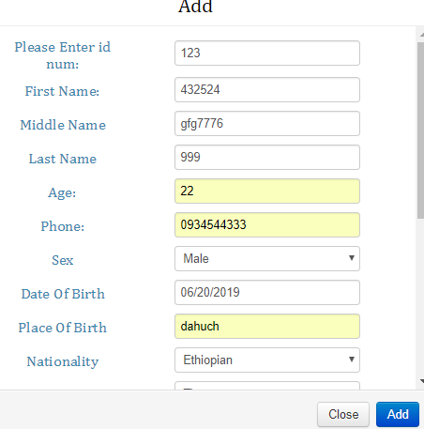

Figure 3:7, Incorrect Id card Certificate

* correct Id card Certificate

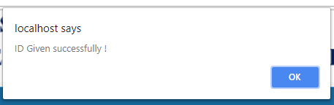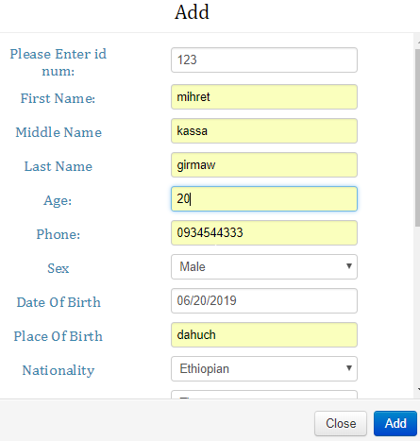

Figure 3:8, Incorrect Id card Certificate

### **Integration Testing**

In this testing part, all the modules will be combined together and tested it for its fitness with each other and with the systems functionality. If error occurs in combining them, the module with problem will be identified and recombined. Both units testing and integrated testing are performed by all team members at the work place.

### **Incremental Testing/Top down testing**

There are two primary modules that will need to be integrating. user interface module and the database module (back-end). The two components, once integrated, will form the complete system. The following describes these modules as well as the steps that will need to be taken to achieve complete integration. An incremental testing strategy will be used to complete the integration.

Module 1 - User Interface Module

This module provides a simple GUI where the user can perform the different actions (functions). This module will be tested separate from the backend to check if each interface (e.g. Add button) is functioning properly, and in general, to test if the mouse-event actions are working properly. The testing is by writing a stub for each element in the interface.

Module 2 – Database Module

The module provides the storage for the data elements of the system and this module will be tested separate from the GUI. In testing this module we will follow the incremental testing method i.e. testing one function first and then keep adding additional function and test it again until all the required functions are tested (Top down approach)When the GUI is combined with the backend module, It will have a complete top down testing.

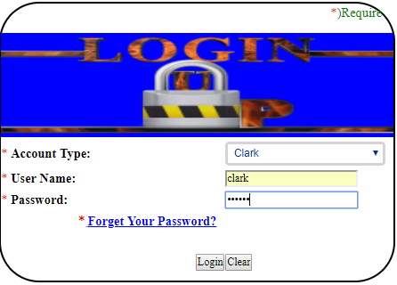

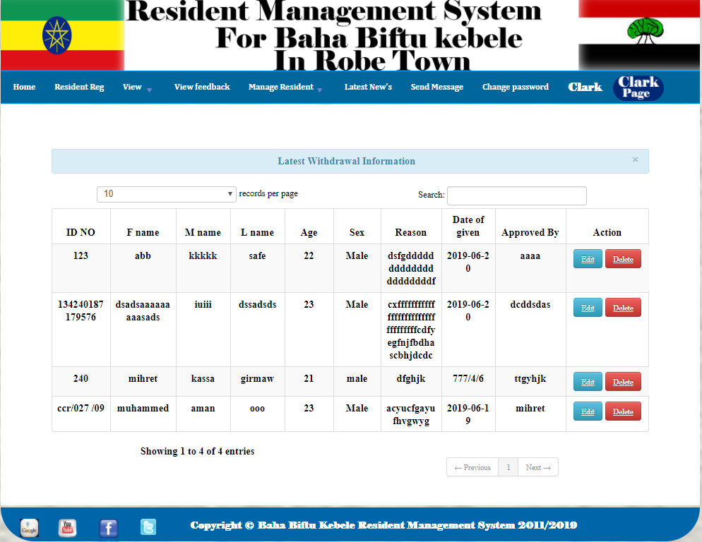

Figure 3:9, Login and view withdrawal Certificate

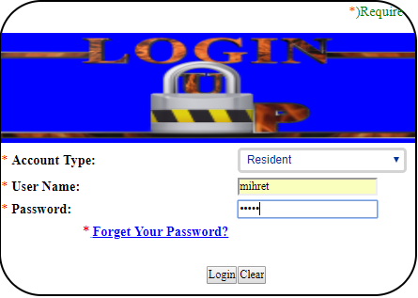 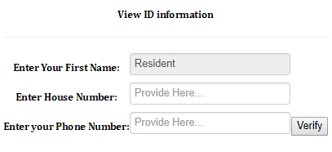

Figure 3:10, Login and change password

**Subsystem/System Testing**

The bringing together of all the programs that a system comprises for testing purposes.all results should be documented on the Test Analysis Report, Test Problem Report and on the Test Analysis Approval Determination. Any failed components should be migrated back to the development phase for rework, and the passed components should be migrated ahead for security testing.

Performance testing: - performance testing is the testing to assess the speed and efficiency of the system and to make sure it is generating results within a specified time as in performance requirement.

## Documentation

At the completion of the project, every activity in the development process will be documented for future reference.

There are two kinds of documentations 1) System documentation 2) User documentation

System documentation is detailed information about a system’s design specifications, its internal workings, and its functionality. It is meant for maintenance programmers. It is further divided into internal and external documentation. Internal documentation is part of the program source code or is generated at compile time.

External documentation includes the outcome of all of the structured diagramming techniques such as DFD and ERD.

User documentation is written or visual information about an application system, how it works and how to use it.

The kinds of user documents are reference guide, user’s guide, release description, system administrator’s guide and acceptance sign-off. The reference guide consists of exhaustive list of the system’s functions and commands usually in alphabetical order.

# Chapter Four

# Result and Dissemination

## Project Layout

Figure 4:1, project Layout

## User Interface

User interface designs are used to model the interactions that users have with software defined in single use case. User interface are an excellent way of exploring system interface. Interface mainly helps to facilitate the interaction between user and the system.

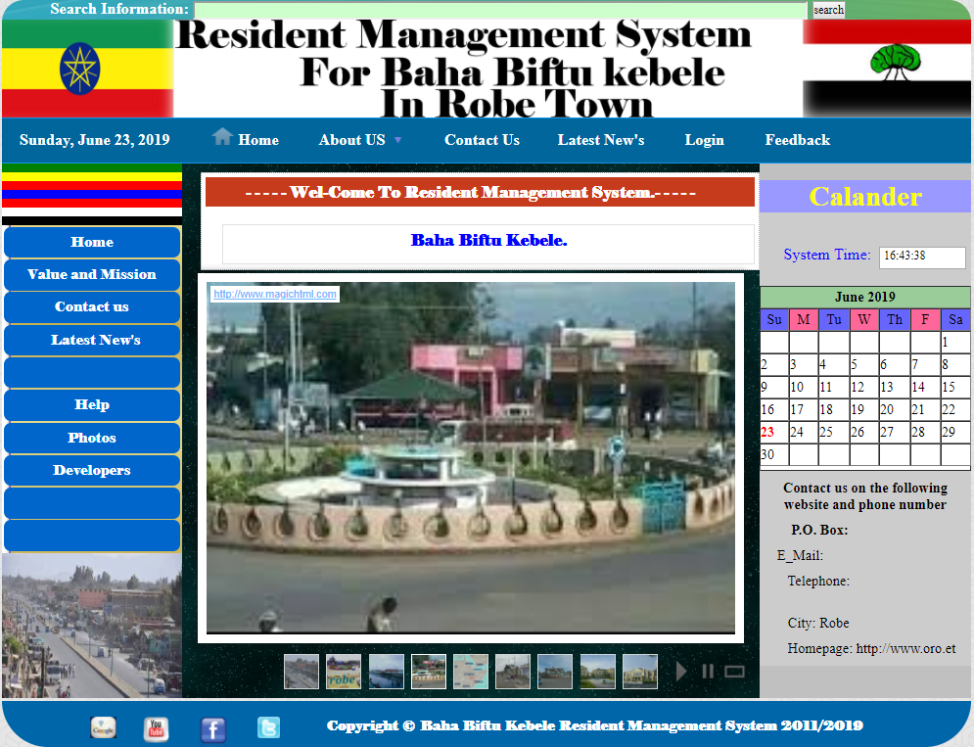

Figure 4:2, User Interface for home Page

Login page: This form appears on the site in which the system deployed is opened and contains some links which lead the user to other page according to his/her privilege, and if the user is authorized user or has an account, he/she will directly go to the page that he/she wants by entering correct category, User name and password.

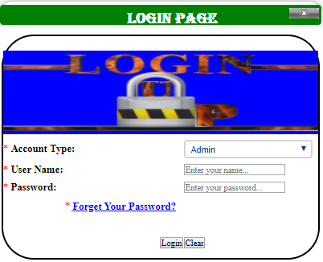

Figure 4:3, User Interface Login Page

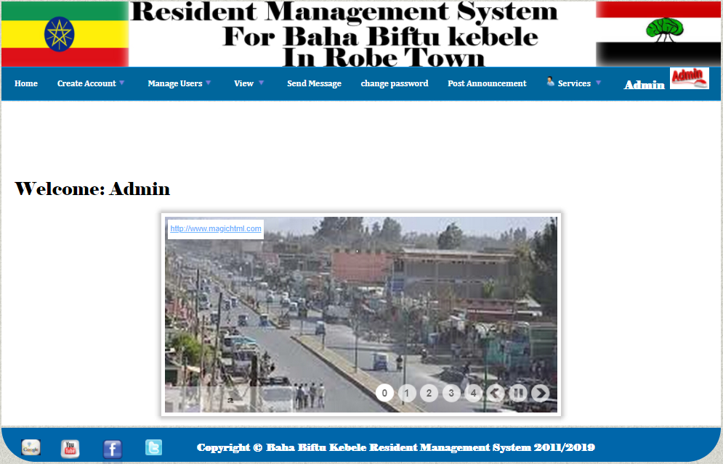

Figure 4:4, User Interface Admin Page

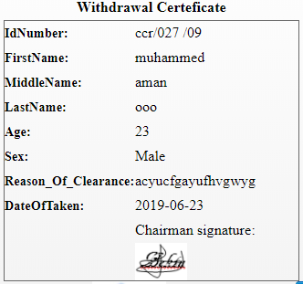

Figure 4:5, user interface for viewing Withdrawal certificate

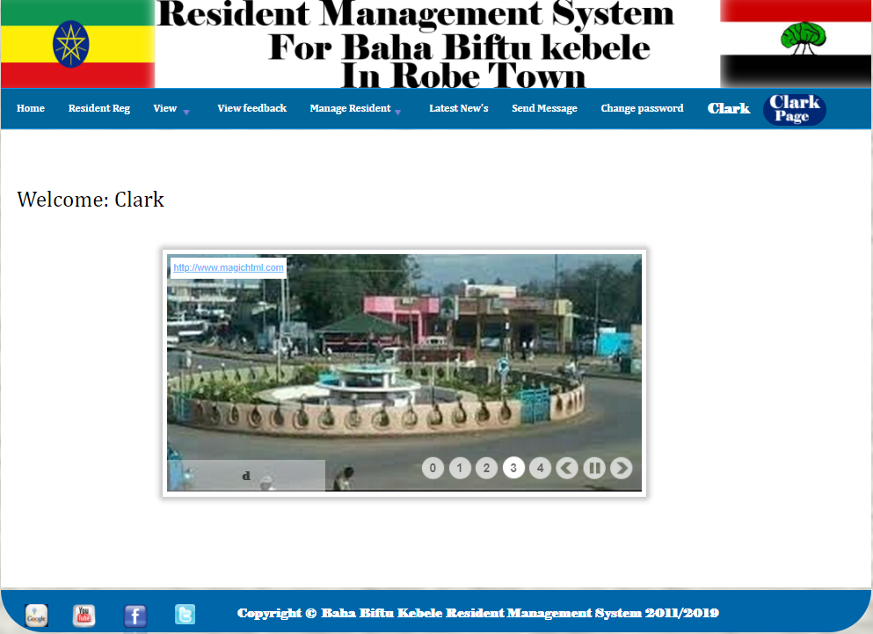

Figure 4:6, User Interface Clark Page

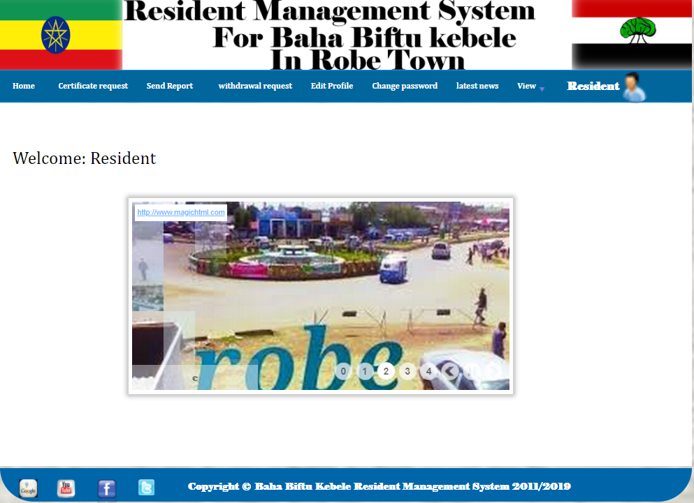

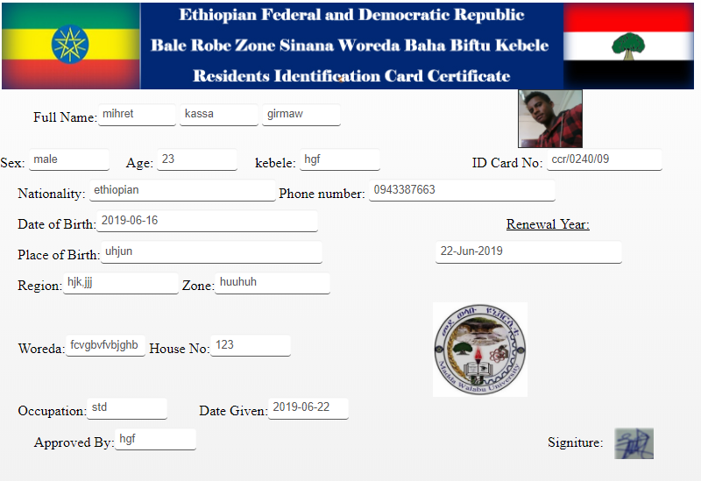Figure 4:7, User Interface Resident Page

Figure 4:8, User Interface for View ID card

**Chapter Five**

# Conclusion and Recommendation

## Conclusion

Baha biftu kebele is a very old age small governmental institution. This Kebele has many services as it was mentioned. However, when we compare this management system to that of other Kebele system it is manual and very poor. This is the main reason to be initiated to develop web based for this governmental institution by designing a project.

In this project our group team develops an efficient system that automates residents’ registry and improves file handling system. The major thing in the proposed system is authenticated Users. Authorized users only will access the system. Unauthorized person won’t be allowed to access the system; they are prevented through verification of user name and Password mechanism. In addition they are prevented by session control mechanism. The need to develop automating registry and filing system of the Baha biftu Kebele is that current activities of the Kebele are time consuming due to manual system.

## Recommendation

According to scope of our project the team develops web based kebele Resident management system because of the time constraint we cannot do beyond to our scopes, but in the future the team believes that this system can be fully operational by having enough time and fully information. Finally the team would recommend that further work will do on the system in order to make the system performance better and can add further functionality.

# Reference

1. Housing and Sustainable Development. Haileyesus, Yohannes Balcha. s.l. : Ethiopian Institute of Architecture, Augest 2014.

2. Resident Management System (RMS). UBC Faculty of Medicine. london : s.n., 2019, Vol. VERSION P2.1.

3. HOUSING AND SUPPORTS FRAMEWORK; INITIATIVE; and CREATING CONNECTIONS:. Celina Dolan, Anita Friesen,Amber Gallant,Keith Hughes,Jim Merchant,Doug Vincent,Charmion Whyte. May 4, 2012.

4. Smart Home Activities:. Ameena Saad al-sumaiti, Mohammed Hassan Ahmed & Magdy M. A. Salama. s.l. : Taylor & Francis Group, LLC, feb 05, 2014. 1532-5008 (Print) 1532-5016 .

5. Home Energy Management Systems:. Dr. NW, Calgary AB T2N 1N4 mdbeaudi@ucalgary.ca. s.l. : University of Calgary, december 22, 2014.

6. Sema, L. (2010). Integrated housing development programmes for urban poverty alleviation and sustainable urbanization: The case of Bahir Dar. Unpublished Master Thesis, Addis Ababa University, Ethiopia.

7. Beyer, G. (1958). Housing: a factual analysis. New York: Macmillan.

8. Teng, R., and Yamazaki, T., “Bit-watt home system with hybrid power supply,” 2nd International Conference on Computer and Automation Enginee.

9. www.google.com/search

# Sample code

for Login Page

<?php

session_start();

if (isset($_POST['Login'])) {

$privilege=$_POST["privilege"];$username=$_POST["username"];

$password= $_POST["password"];$crypt_pass = md5($password);

$db = mysql_connect("localhost","root","") or die ("Error connecting to database.");

if(!$db){echo "no connection established"; }

mysql_select_db("onlinekebele",$db) or die("Couldn't select the database.");

$qry= "select * from users where username='".$username."' and password='".$crypt_pass ."' and privilege='".$privilege."' ";

$results = mysql_query($qry,$db) or die(mysql_error());

$count=mysql_num_rows($results);

if($count<='0'){?>

<font color="white"><script>

window.alert('please match privlage,username and password'); window.location.href='index11.php';

</script>

<?php }else{ while ($row = mysql_fetch_array($results)) {

$_SESSION['user_id']=$row['user_id'];

$state=$row['state']; if($state=="active")

{if($privilege=="Admin"){

echo'<br>';?><script> window.location.href='index1.php';

</script><?php}

else if($privilege=="Clark"){

$_SESSION['user_id']=$row['user_id'];echo'<br>';?>

<script>window.location.href='clarkindex.php';

</script> <?php}

else if($privilege=="Resident"){

$_SESSION['user_id']=$row['user_id'];

echo'<br>';?>

<script>window.location.href='userindex.php';

</script><?php}else if($privilege=="--select_role--"){

$error= "Select Privilege.";}}

else

{$error="this Account is deactivated or inactive";

//header('location:index1.php');

include("index11.php");

?></font><?php

}}}}?>

Sample code for resident registration

<?php

include('db.php'); if (!isset($_FILES['image']['tmp_name'])) {

echo "";}else{$file=$_FILES['image']['tmp_name'];

$image = $_FILES["image"] ["name"];

$image_name= addslashes($_FILES['image']['name']);

$size = $_FILES["image"] ["size"]; $error = $_FILES["image"] ["error"];if ($error > 0){ die("Error uploading file! Code $error.");

}else{ if($size > 10000000) //conditions for the file{

die("Format is not allowed or file size is too big!"); }

else{move_uploaded_file($_FILES["image"]["tmp_name"],"upload/" . $_FILES["image"]["name"]);$plocation=$_FILES["image"]["name"];

$fname= $_POST['fname'];$mname= $_POST['mname'];

lname=$_POST['lname'];$age=$_POST['age'];

$sex= $_POST['sex']; $dateofbirth= $_POST['dateofbirth'];

$placeofbirth= $_POST['placeofbirth']; $region= $_POST['region'];

$zone= $_POST['zone']; $woreda= $_POST['woreda'];

$nationality= $_POST['nationality'];$houseno= $_POST['houseno'];

$occupation= $_POST['occupation']; $phone= $_POST['phone'];

$reason= $_POST['reason']; $approve= $_POST['approve'];

$dateofreg= $_POST['dateofreg'];

mysql_query("insert into resident (fname,mname,lname,age,sex,dateofbirth,placeofbirth,region,zone,woreda,nationality,houseno,occupation,phone,plocation,reason,dateofreg,approve)values('$fname','$mname','$lname','$age','$sex','$dateofbirth','$placeofbirth','$region','$zone','$woreda','$nationality','$houseno','$occupation','$phone','$plocation','$reason','$dateofreg','$approve')")or die(mysql_error());?> <script>window.alert('User Added Successfully'); window.location.href='searchhouse.php'; </script>

<?php}

}}?>

Sample code for id card registration

<?php

include('db.php');include('idindex1.php'); if (!isset($_FILES['image']['tmp_name'])) {echo "";}else{ $file=$_FILES['image']['tmp_name'];$image = $_FILES["image"] ["name"];$image_name= addslashes($_FILES['image']['name']);

$size = $_FILES["image"] ["size"];$error = $_FILES["image"] ["error"];if ($error > 0){ die("Error uploading file! Code $error.");

}else{if($size > 10000000) //conditions for the file{

die("Format is not allowed or file size is too big!"); }

else{move_uploaded_file($_FILES["image"]["tmp_name"],"upload/" . $_FILES["image"]["name"]);$location=$_FILES["image"]["name"]; $id_no=$_POST['id_no']; $fname=$_POST['fname']$mname=$_POST['mname']; $lname=$_POST['lname'];$age=$_POST['age']; $sex=$_POST['sex'];

$phone=$_POST['phone'];

$dateofbirth= $_POST['dateofbirth']; $placeofbirth= $_POST['placeofbirth']; $nationality= $_POST['Nationality'];

$region= $_POST['region']; $zone= $_POST['zone']; $woreda= $_POST['Woreda']; $houseno= $_POST['houseno']; $occupation= $_POST['occupation']; $dategiven= $_POST['dategiven'];

$Kebele= $_POST['Kebele']; $approvedby= $_POST['approvedby'];

mysql_query("insert into id_card (id_no,fname,mname,lname,age,sex,phone,dateofbirth,placeofbirth,Nationality,region,zone,Woreda,houseno,occupation,dategiven,Kebele,approvedby,location)values('$id_no','$fname','$mname','$lname','$age','$sex','$phone','$dateofbirth','$placeofbirth','$nationality','$region','$zone','$woreda','$houseno','$occupation','$dategiven','$Kebele','$approvedby','$location')")or die(mysql_error());

?> <script> window.alert('ID Given successfully !');

window.location.href='idindex1.php';</script>

<?php}

}}?>

Sample code for change password

<?php include('dbcon.php'); ?> <?php $conn=mysql_connect("localhost","root","");mysql_select_db("onlinekebele",$conn);if (isset($_POST['change_password'])) { require("dbcon.php");$username = $_POST['username']; $pass = $_POST['password']; $confirmpassword = $_POST['confirmpassword'];

$new_password = $_POST['new_password']; $resulsasst = mysql_query("SELECT * FROM users WHERE username = '$username' and password = '$pass'");$counssst = mysql_num_rows($resulsasst);

if ($counssst ==0) {echo "user name and password is not correct Please Insert Correctly ! ";echo '</strong></div>';} else

{$passw = $_POST['new_password']; if (strlen($passw) <= 3)

{

echo '<div class="alert alert-dismissable alert-e">';

die('<strong>' . "Password Must Be Grater Than 3 Characters !" . '</strong>'); echo '</div>'; }if (substr($new_password, 0, 5) == substr($username, 0, 5)) {echo '<div class="alert alert-dismissable alert-error"><strong>'; die("Your Password Must Have A Big Defferent From Your Your Username, Try Other Password !");

echo '</strong></div>'; }if ($new_password != $confirmpassword) {

echo '<div class="alert alert-dismissable alert-error"><strong>';

die("Your New Password is not the Same With Confirm Password,please Enter The same Password");echo '</strong></div>';

}$sqll = "update users set password='$new_password' where username = '$username' ";$res = mysql_query($sqll) or die("unable to change" . mysql_error());//echo '<script type="text/javascript">alert("You are successfully rest your password please login here");window.location=\'Anti_Corruption.php\';</script>';

echo '<font color="red" size="3">' . "Successfully Changed!;" . '</font>'; echo '</strong></div>';

}}

?>

Sample code for withdrawal certificate Registration form

<?php

$conn=mysql_connect("localhost","root","");

mysql_select_db("onlinekebele",$conn);

if(isset($_POST['clearance']))

{

if(!$conn)

{

die('Could not connect: ' . mysql_error());

}

mysql_select_db("onlinekebele", $conn);

$sql="INSERT INTO withdrawal(IdNumber,FirstName,middleName,LastName,age,sex,Reason_Of_Clearance,approve,Date_Of_Taken)

VALUES

('$_POST[id]','$_POST[firstname]','$_POST[middleName]','$_POST[lastname]','$_POST[age]','$_POST[sex]','$_POST[Reason_Of_Clearance]','$_POST[approve]','$_POST[date]')";

if (!mysql_query($sql,$conn))

{

die('Error: ' . mysql_error());

}

else

{?>

<script>

alert("your Withdrawal has been successfully Saved!")

</script>

<?php

}

}

mysql_close($conn);

?>

# 

# **APPENDIX**

Dear respondents, first of all my respondents I would like to say thanks for your willingness to give me genius information. This questionnaire is to collect data or to get relevant information at Baha biftu kebele resident management system.

I would wish to collect information from you through this questionnaire. Please fill this questionnaire in the space provided.

1. Respondent details

Undergraduate: __________ Postgraduate Course: ____________ Year of study: ___________ Sex: ___________ Residence (out- side or in side?): ___________

2. What difficulties do you observe on the current resident system? __________________________________________________________________

3. In the new computerized system of resident, what facilities do you wish to be included? __________________________________________________________________

Questions asked during requirement analysis using an interview:

Q1.What is the objectives of this kebele?

Q2. What is the mission of the kebele?

Q3. How many customers do you have?

Q4. How does your current system work? Is it manual, computerized or semi computerized?

Q5. How do you generate customer information’s?

Q6. How the existing systems work?

Q7. How new customer can get service from the kebele?

Q8. How happen if customer leave the kebele and come again?

Q9. How many time a new customer lives without the kebele’s ID?

Q6. What criteria would have to be fulfilling to get kebele’s ID card?

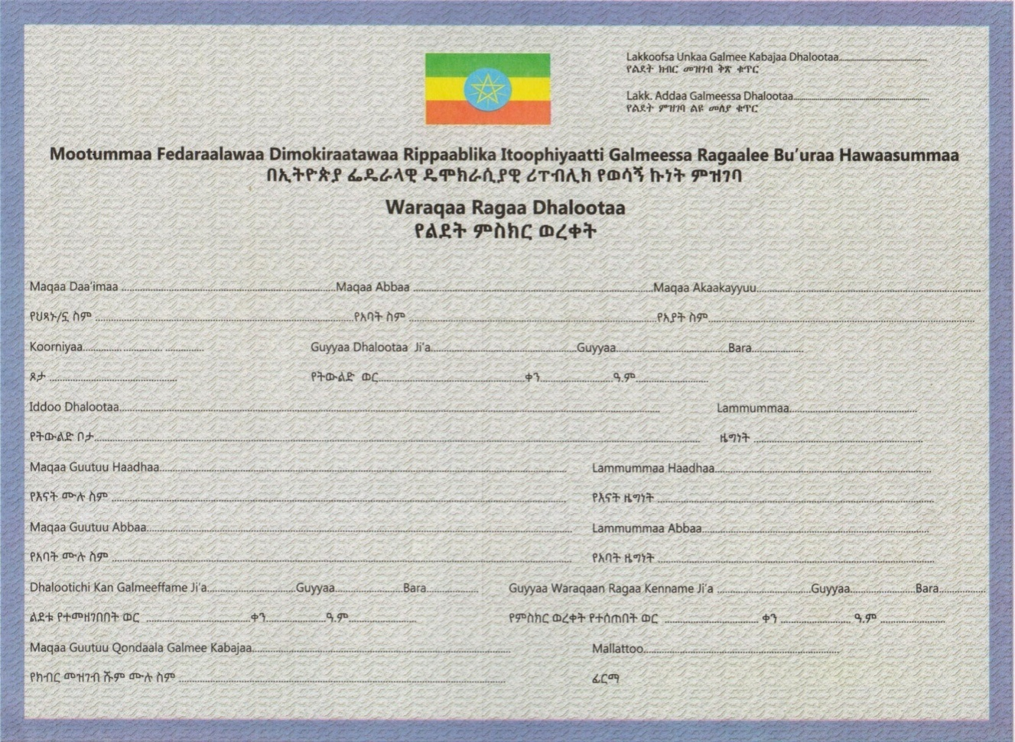  Birth certificate form

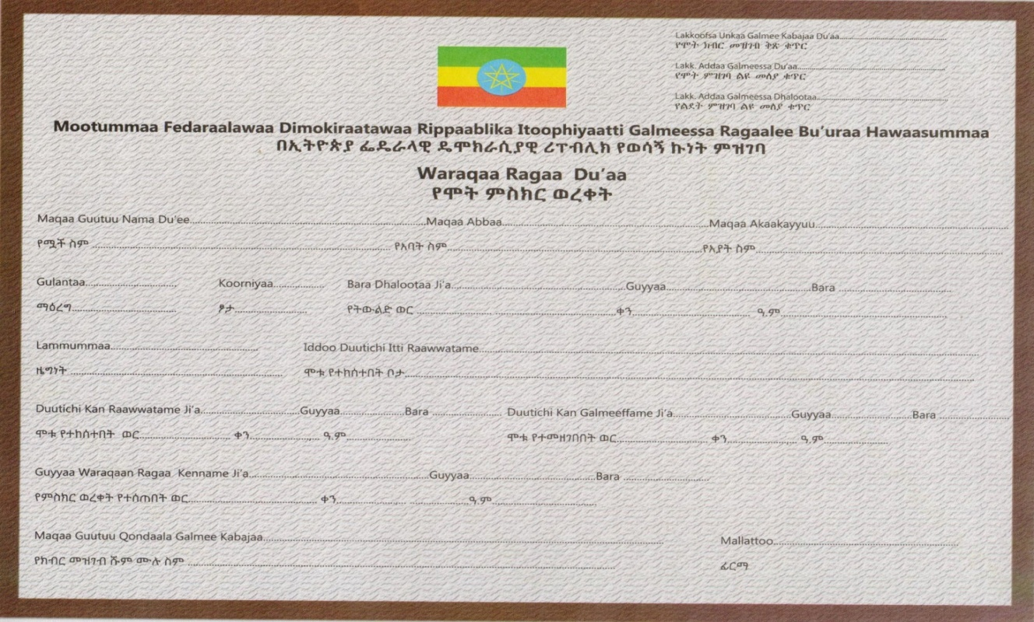

Death certificate form